UNIT TWO GROUP ASSIGNMENT

Pricing to Maximize Profits

Overview
The goal of this course is to give you the knowledge and tools that you need to successfully design and offer products and services to customers. To put your skills from Unit Two into practice, you will work with your group to review the historical data provided, conduct a thorough analysis, and then determine the unit price that should be charged to the retailers. Be sure that you are able to justify your unit price with data.
The dataset is available on the assignment page.
Completion of this project is a course requirement.
Except as indicated, use this document to record all your Unit Two assignment work and responses to any questions. At a minimum, you will need to turn in a digital copy of this document to your facilitator as part of your project completion. You may also have additional supporting documents that you will need to submit. Your facilitator can provide feedback to help you work through your findings.
Note: Though your work will only be seen by those grading the course and will not be used or shared outside the course, you should take care to obscure any information you feel might be of a sensitive or confidential nature.
Grading details and directions to submit your Unit Two assignment can be found on the assignment page. Do not hesitate to contact your facilitator if you have any questions about the Unit Two assignment.

Group Assignment
Please work with your previously established group.

Scenario for Analysis
As a consultant for a national brand manufacturer, you have been assigned to determine the item unit price for the retailer of Brand #1. A private label has been gaining share within many of the manufacturer’s retail accounts and you have decided to price Brand #1 to potentially counter this problem.
To assist in your deliberations, some historical data have become available from one of your key accounts that has no promotions in it. You have decided to use this data to determine the optimal price that will be charged to the retailer. You do not set the price to the consumer (i.e., the retail price) but only the price to the retail account. The retailer’s category manager, in conjunction with the retailer’s pricing department, sets the retail price. However, any changes in your price to the retailer will have a significant effect on the retail price.
Within the accompanying Excel file, Table 1 provides you with the price per unit charged by the retailer to the consumer, the cases sold each week by the retailer, and the retailer’s case cost each week for your brand and for the private label. There are 24 units per case. Manufacturing cost data for the manufacturer are also given in the table. In addition to manufacturing cost, the only other variable cost incurred by the manufacturer is a selling cost of $10.00 per case. You do not know the manufacturing costs of the private label.

Instructions
Using the data in Table 1, you are tasked with empirically determining the optimal price to charge the retailer. Address each of the assignment questions below.
Note: please conduct and report all analyses in terms of units of products, not cases and submit only word or PDF documents, no longer than the title page plus six pages. No Excel files please.

- (2 points) Compute summary statistics to understand the data:
- Plot the sales data for the two brands separately, over time.
- Report the (simple) average retail price per unit of each brand. Compute the $ price gap between the brands at the average prices.
- Report the average weekly % retail margin of each brand.
- Report the average weekly unit sales of each brand.
- Report the average weekly market share of the two brands (within this retail account) based on unit sales. Assume the category consists of these two brands only.
- Report the average weekly profits (in $) of the retailer and the manufacturer. Remember that the retailer gets profits from selling brand 1 and the private label.
a. 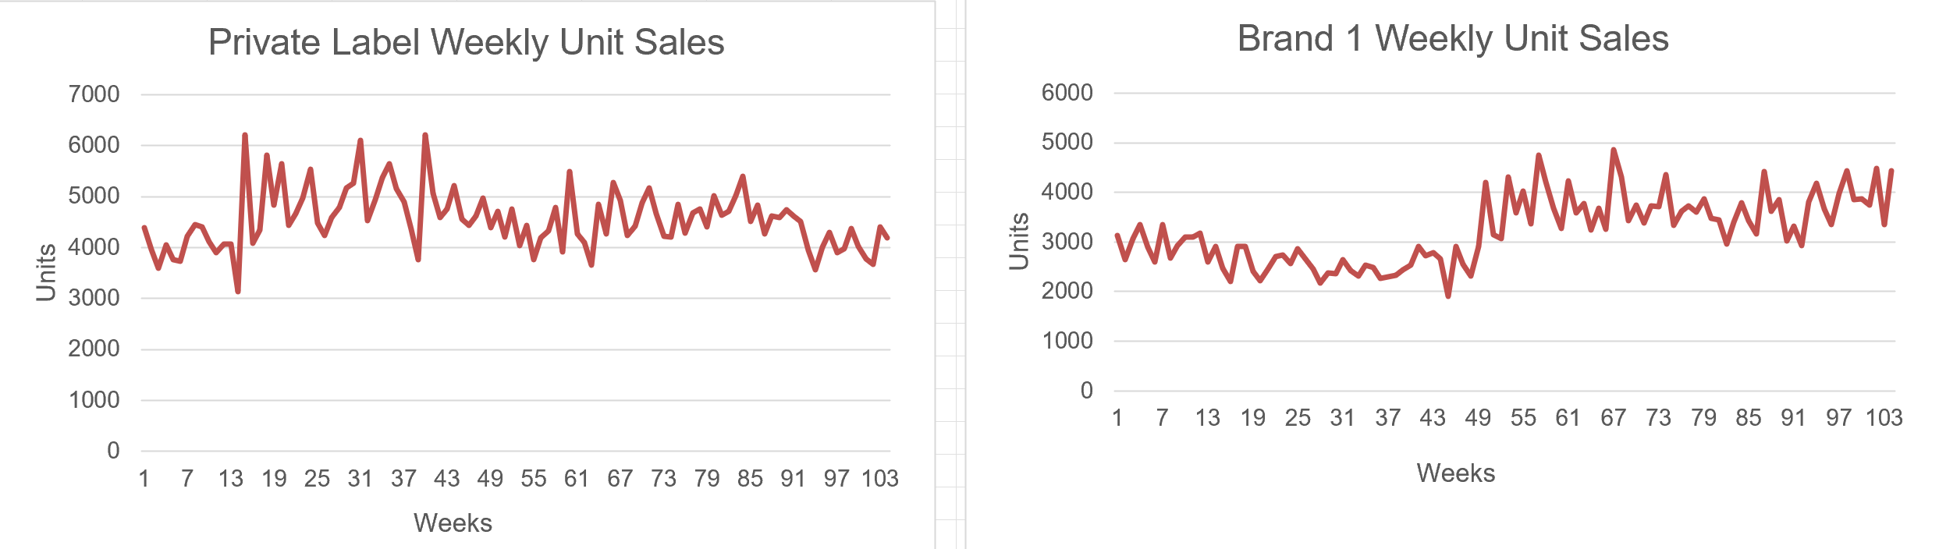

b. Private Label average retail price: $2.15 per unit
Brand 1 average retail price: $2.61 per unit
Average price gap: $0.46 per unit, with Brand 1 priced higher.

c. Private Label average retail margin: 23.09%
Brand 1 average retail margin: 17.12%

d. Private Label average weekly unit sales: 4,545 units
Brand 1 average weekly unit sales: 3,221 units

e. Private Label share = 58.69%
Brand 1 share = 41.31%

f. Average weekly retailer profit: $3,688.52
Average weekly manufacturer profit (Brand 1): $1,801.69

- (3 points) Determine the variables that should be included in the marketing mix models (one model each for Brand 1 and the private label). Estimate the models. Use the semi-log (or exponential) form of the model. Show the regression outputs.

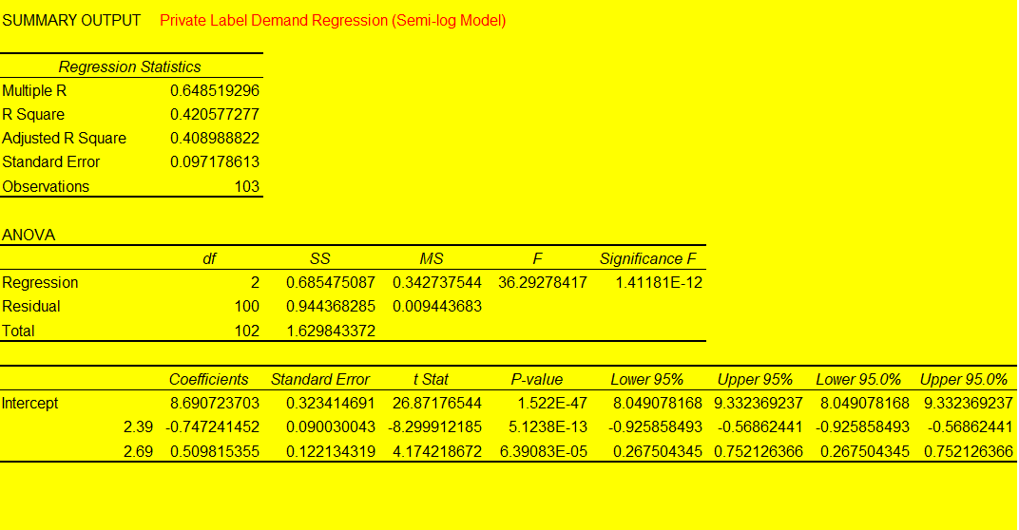
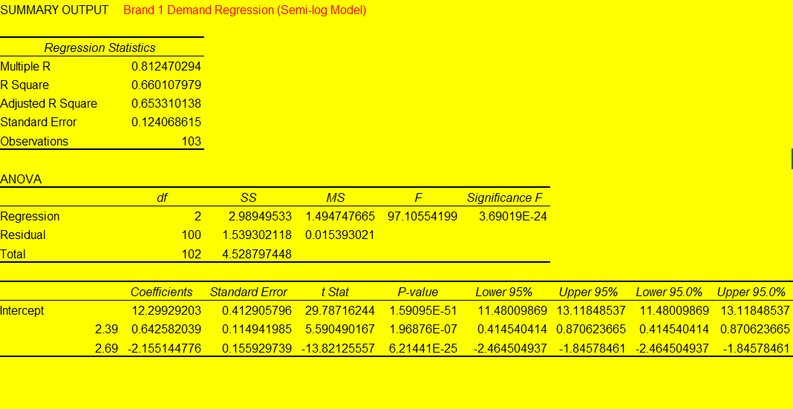
Note: Do not include a trend variable in the model. Do not include or control for seasonality in the model.
Two semi log demand models were estimated for Private Label and Brand 1 using retail prices as explanatory variables.

For Private Label, the model shows moderate explanatory power with R squared equal to 0.421. The coefficient for Private Label price is minus 0.747 with p value less than 0.001, indicating that higher Private Label prices significantly reduce demand. The coefficient for Brand 1 price is 0.510 with p value less than 0.001, suggesting that increases in Brand 1 price shift demand toward Private Label products.

For Brand 1, the model shows stronger fit with R squared equal to 0.660. Brand 1 price has a strong negative impact on demand with coefficient minus 2.155 and p value less than 0.001, while Private Label price has a positive effect with coefficient 0.643 and p value less than 0.001, again indicating substitution between the two brands.

All price effects are statistically significant, confirming strong competitive interactions between the brands.

- (4 points) Assess the validity of the models based on
- face validity of the estimated coefficients,
- statistical significance of the overall models, and
- statistical significance of estimated coefficients.
Next, plot the predicted versus actual sales (within the estimation sample) for each brand and for the category. You should have three graphs in total, one each representing; Brand #1, private label, and the category. The horizontal axis represents time, and the vertical axis represents sales. The category sales are found by calculating the sum of sales of the two brands.
Answer here…

- (7 points) Next, you will determine the optimal selling price of the manufacturer using Excel (or calculus) for an average week. Make reasonable assumptions about manufacturer costs and be sure to state them in your response. Remember that the retailer sets the retail price. Assume that the retailer has margin goals that serve as norms. Please state your assumptions about the retailer clearly.

Answer here…
With regard to the competitor’s price, consider the following two scenarios (these reflect our assumptions about how the retailer will price the private label) and provide the optimal selling price of the manufacturer under each scenario separately:
- Assume that the private label’s retail price is fixed at the average level in the data.
- Assume that the private label’s retail price is always 35 cents below the retail price of Brand 1.
Note: Ensure that the steps of your analysis are clear, or we cannot give partial credit.
Answer here…

- (4 points) Compute the “implied” values of different variables at the optimal prices in each of scenarios 4(a) and 4(b), and compare them with the current situation. Fill in the table below to represent a typical week. Take the retailer’s cost of the private label to be the average cost in the historical data. The last column can be filled in by reproducing your answers to question 1 (d), (e), and (f).
For scenarios 4(a) and 4(b), identify one concern about the reasonableness of the assumption about the retailer’s pricing behavior with respect to the private label.

Answer here…

 | Scenario 4(a) | Scenario (4(b) | From Qs1
How many units will the retailer sell of each brand?  - Brand 1  - Private Label | Answer here… | Answer here… | Answer here…
What will be the market shares of the two brands?  - Brand 1  - Private Label | Answer here… | Answer here… | Answer here…
What will be the total weekly profits of the  - Retailer  - Manufacturer | Answer here… | Answer here… | Answer here…

